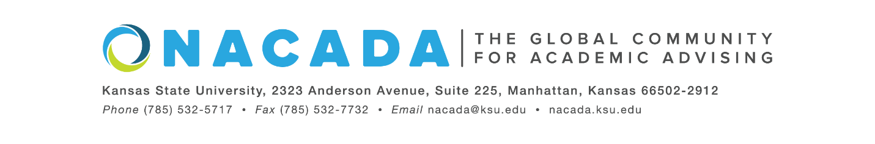
NACADA: The Global Community for Academic Advising
INSERT DATE
For Immediate Release
For more information about the Global Awards Program for Academic Advising, visit: https://www.nacada.ksu.edu/Programs/Awards/Global-Awards.aspx
Or Contact: Lizbeth Alcantara, NACADA: The Global Community for Academic Advising, nawards@ksu.edu

INSERT NAME, of INSERT INSTITUTION, was selected as an Outstanding New Advisor – Primary Role Award Winner as part of the 2022 Global Awards Program for Academic Advising from NACADA: The Global Network for Academic Advising. This award is presented to advisors who have demonstrated qualities associated with outstanding academic advising of students and who have served as a professional advisor for a period of three (3) or fewer years.
Award winners support NACADA’s Core Values, represent the best professional practices in advising and have a great impact on their students and colleagues. The award will be presented during a ceremony at the NACADA Annual Conference in Portland, this fall. More details on this award category may be found here: https://www.nacada.ksu.edu/Programs/Awards/Global-Awards/Outstanding-New-Advisor.aspx
Since 1983, NACADA has honored individuals and institutions making significant contributions to the improvement of academic advising. Our goal is to promote quality academic advising and professional development of members to enhance the educational development of students.
NACADA’s membership has grown to over 14,000 faculty, professional advisors, administrators, counselors, and others in academic and student affairs concerned with the intellectual, personal, and vocational needs of students. In addition, NACADA is the representative and advocate for academic advising and for those providing that service to higher education.
-end-

